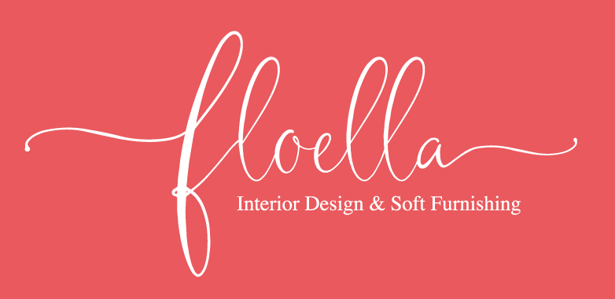

Floella, a boutique interior design and soft furnishing business, is run by interior designer Sarah Davies, who has brought a wealth of interior design experience to the Cotswolds, following a career in London that spanned twenty years’.
Working on everything from one room ‘refreshes’ to full re-designs, Sarah is committed to offering clients the best service, advice and value for money.
Contemporary sensibilities marry with a love of pattern and colour to create Sarah’s trademark design style. That said, she always creates for you the client, to make your design dreams a reality.

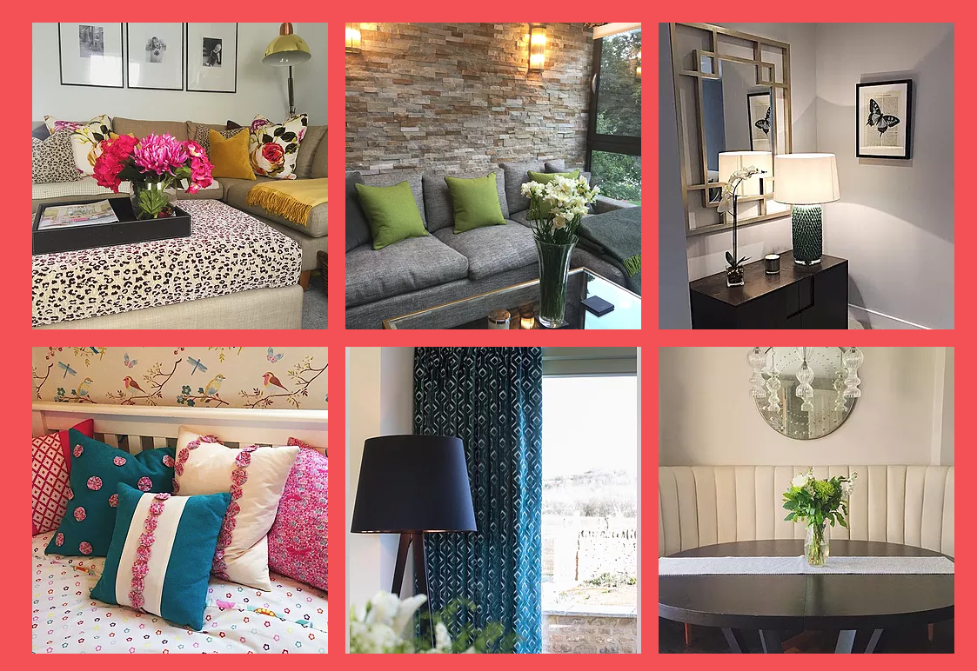

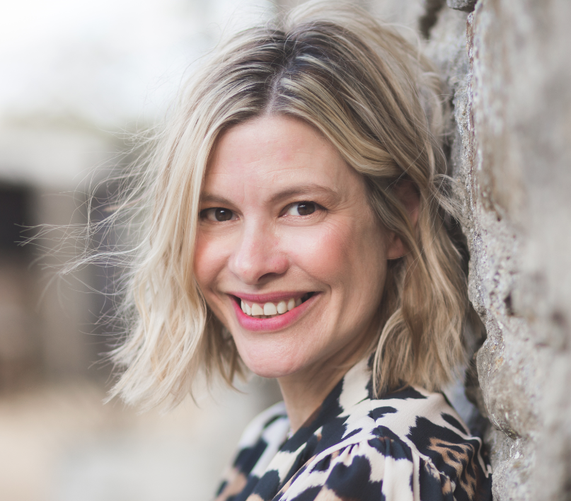
A love of art and fashion led to a career in interiors by way of training with a small company in London making bespoke curtains and blinds. It was here that Sarah started to hone her talents in creating high-end soft furnishings. This first hand talent and experience give Sarah the upper hand in understanding how things are made and which fabrics work well together. Making sure that you get a great service and experience.
Following this up with 16 years at Cameron Broom in London, including a period as Head Residential Designer, Sarah has a breadth of expertise that leaves her very much in demand far and beyond the Cotswolds where she is now based.

FLOELLA – Interior Design and Soft Furnishings
www.floella.uk
davies.floella.sarah@gmail.com
07487238287

